Python and Jupyter Notebook Installation Instructions

Fundamentals of Generative AI for Item Development

Author: Henry Makinde/ Hope Adegoke/ Mubarak Mojoyinola

# Python Download Free Icons Python Programming Computer Social Tutorial ICON favicon | FreePNGImg

Python is supported on a range of operating systems. In general, Linux and macOS have Python pre-installed. For other operating systems like Windows, Python can be downloaded from the website (<https://www.python.org/downloads/>).

For this course, we will install Python through an open-source data science package management system called **conda**. It is developed by Anaconda, Inc. and runs on Windows, macOS and Linux.

Python has two versions:

* + Python 2.x
  + Python 3.x

Of these two, Python 2 is older and is no longer supported or maintained by Python.org. So, we will use the latest stable version of Python 3 that comes with the conda installer.

There are two types of conda installers:

|  |  |  |
| --- | --- | --- |
| **Anaconda** | A full setup with IDE, GUI, CLI and scientific packages | Needs 3GB+ disk space |
| **Miniconda** | Minimal installer with conda, Python and dependencies | Needs 400MB disk space |

We recommend downloading **Miniconda** for its lean setup, it contains all the essential tools required for this course. Additioal Python packages can be easily installed using the **conda** or **pip** package managers.

To download Miniconda, visit the url: <https://docs.conda.io/en/latest/miniconda.html> Choose the installation file by

* + your operating system - Windows or macOS
  + your computer’s CPU bit size - 32 or 64 bit (most present day computers are 64 bit)
  + Python 3.x version

Once you have the installation file downloaded to your computer, follow the below operating system specific instructions.

## Installation Steps: WINDOWS OS

* + The first step is to verify if your computer already has Python installed. Here’s a simple way to check that:
    - Open Command Prompt from the Windows Start menu
    - Type python --version and press Enter
    - If Python is installed, a version number will be returned
    - A black background with white text

      AI-generated content may be incorrect.If Python is not installed, a blank line will appear
    - Remember this, as it will be useful later during Miniconda installation
  + Now open the Miniconda installation file that you have downloaded to your computer

* + 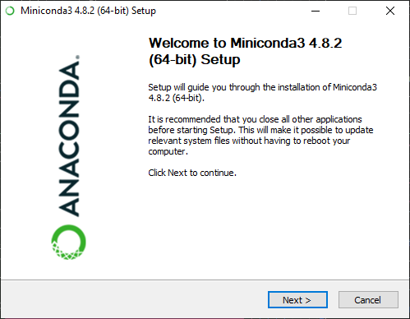A setup guide window will appear (similar to the below image), click *Next*.
  + 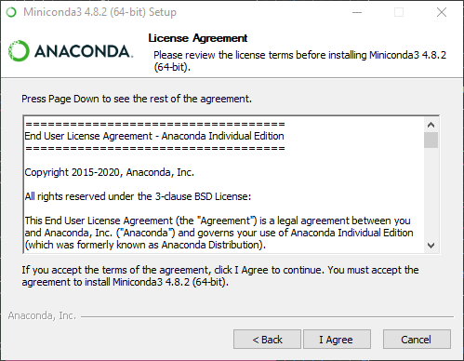Click *I Agree* on the license agreement window and proceed to the next window.
  + Choose the *Just Me* option on *Install for* window. This is important if you are installing Miniconda on a work computer as you might not have the administrator privileges.

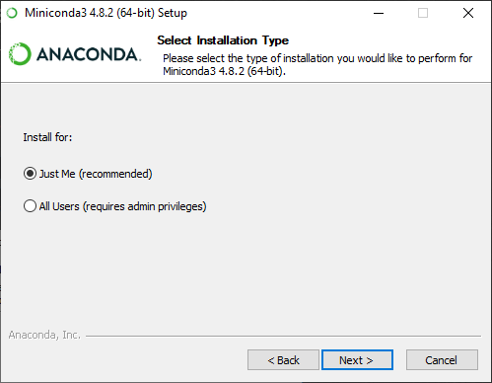

* + Select the installation folder for Miniconda, we recommend the default option at C:\Users\<your-username>\Anaconda3\. Make sure not to have spaces in your file path.

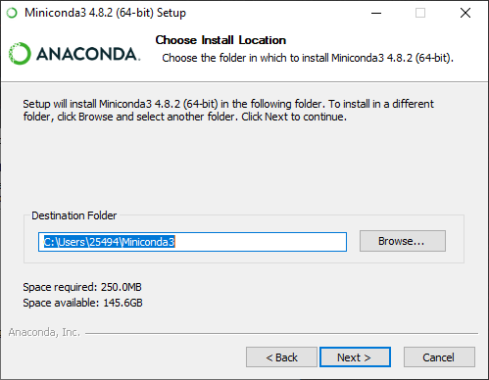

* + The next step is an important part of the installation process.
    - Keep the first option “*Add Miniconda3 to my PATH environment variable*” checked so that you can use **conda** directly from your Command Prompt (Windows) or Terminal (Mac OS).
    - The second option “Register Miniconda3 as my default Python” is selected by default. You can keep this selected if this is your first Python installation and if you want to use this Python version in other applications. If you already have Python pre-installed and using it for other applications, then you might want to uncheck this option as well.

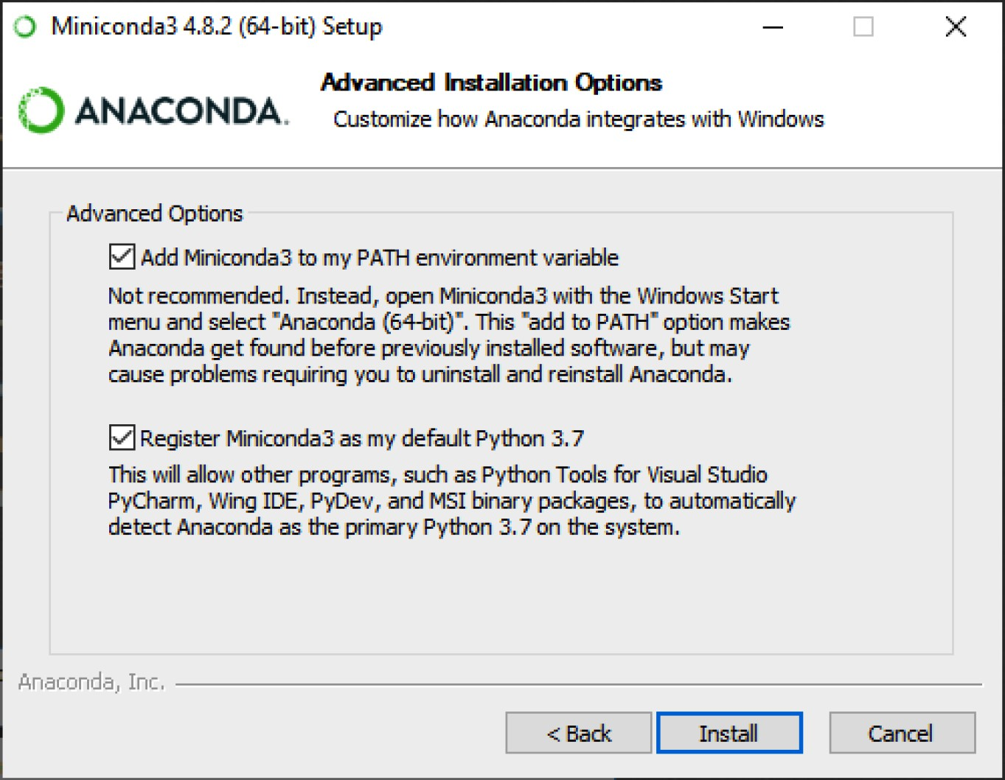

* + The next window will install Python, conda and other required dependencies. This might take 1-2 minutes. Proceed to the *Next* window once installation is complete.

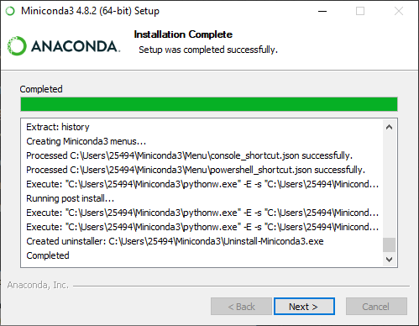

* + Click *Finish* and exit setup. You can refer to the resources or opt out based on your preference.

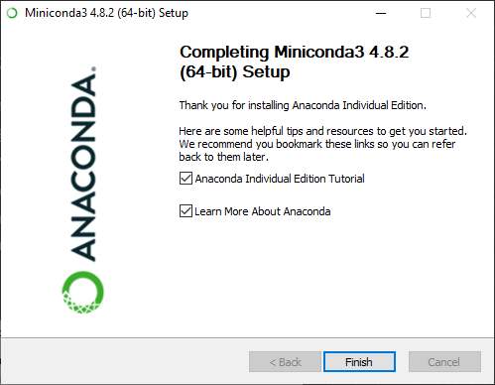

* + Optionally, you can restart your computer now.

## Verify Installation:

* + Open Anaconda prompt from Windows Start menu.

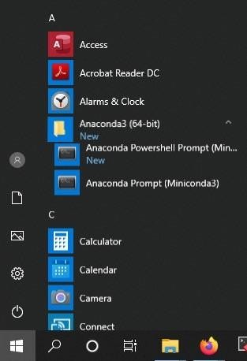

* + Enter conda list to check if **conda** is installed and working, this will display a list of installed packages and their versions.

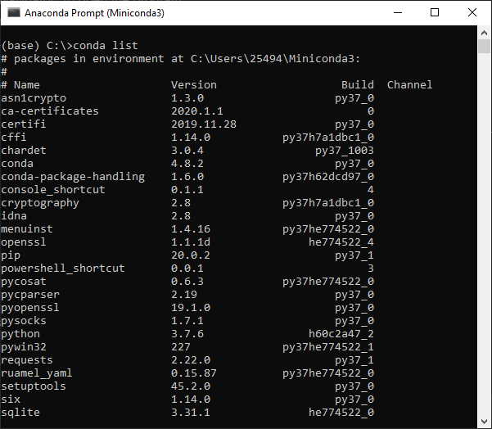

* + Enter the command python. This command runs the Python shell. If conda is installed and working, the version information it displays when it starts up will include *Anaconda*. To exit the Python shell, enter the command quit().

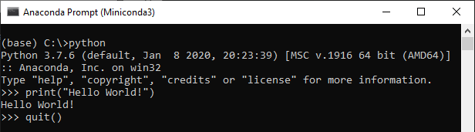

## Installation Steps: macOS

* + Miniconda has two types of installation files for macOS:
    - Package file (.pkg) for GUI based installation
    - Shell file (.sh) for installation through Terminal
  + Download either of these file types based on your preference.

## Package File Installation (GUI):

* + Open the installer file you have downloaded to your computer.
  + 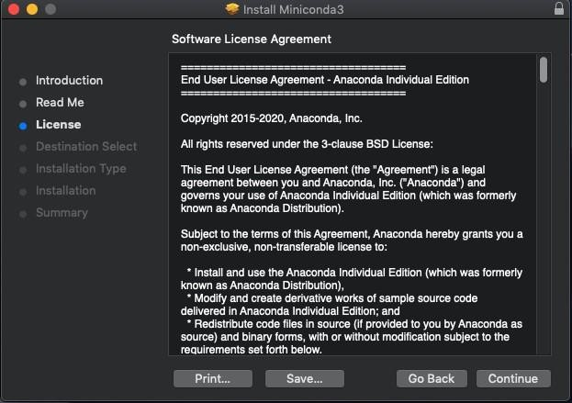Follow through the steps on the installer screen by agreeing to the license terms.
  + Choose the default option *Just Me* on the Destination select window, this is important if you do not have the administrator privileges for the computer. The default installation

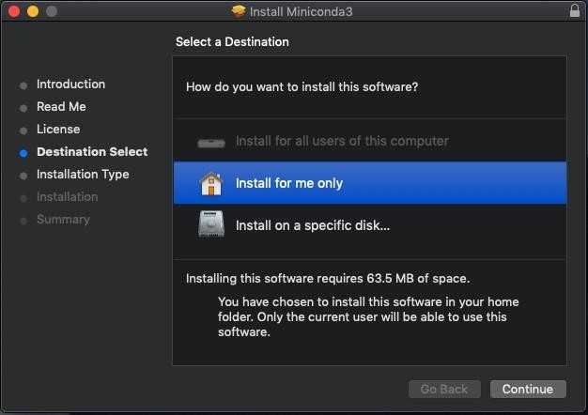path for GUI based installation is at /Users/<your-username>/opt folder.

* + 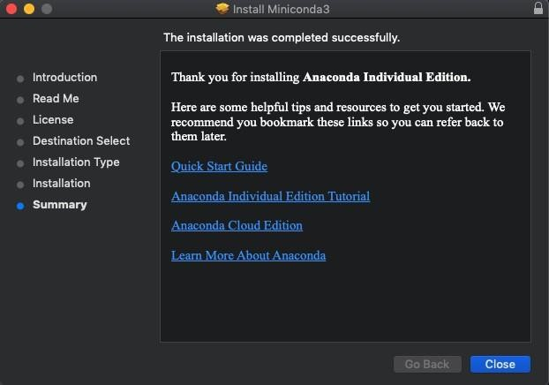Continue through the installation and close the installation window once complete.

## Terminal Installation:

* + Open the Terminal and navigate to the folder where the installation file is downloaded to.
  + Run the bash command followed by the filename like: bash Miniconda3-latestMacOSXx86_64.sh
  + 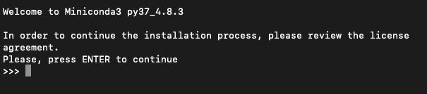Follow through the screen prompts and agree to license terms by entering yes
  + Next, select the default installation location by pressing ENTER key. Unlike the

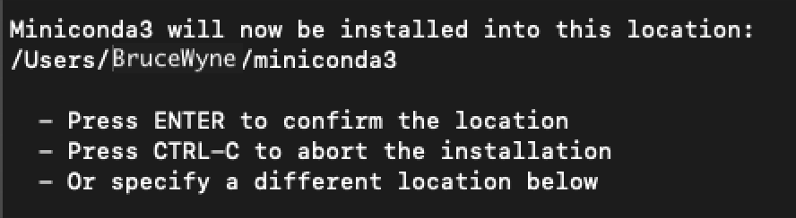.pkg file, the default path for shell installation is at: /Users/<your-username>

* + The installer prompts “*Do you wish the installer to initialize Miniconda3 by running conda init?*” Type yes

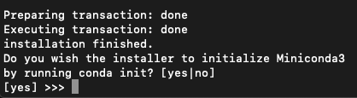

* + This will make changes to your bash_profile at: /Users/<your- username>/.bash_profile. Once the installation is complete, close and reopen the Terminal.

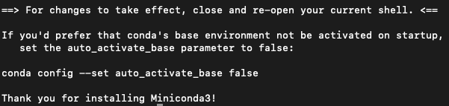

## Python installation without Anaconda (Windows 10)

1. Apart from this course, you can install Python directly without using Anaconda package manager.
   1. Download the latest Python 3 release from [https://www.python.org/.](https://www.python.org/) Choose either the *web-based installer* or the *executable installer*.
   2. Run the installer. Select the option to *Add Python 3.x to PATH*.

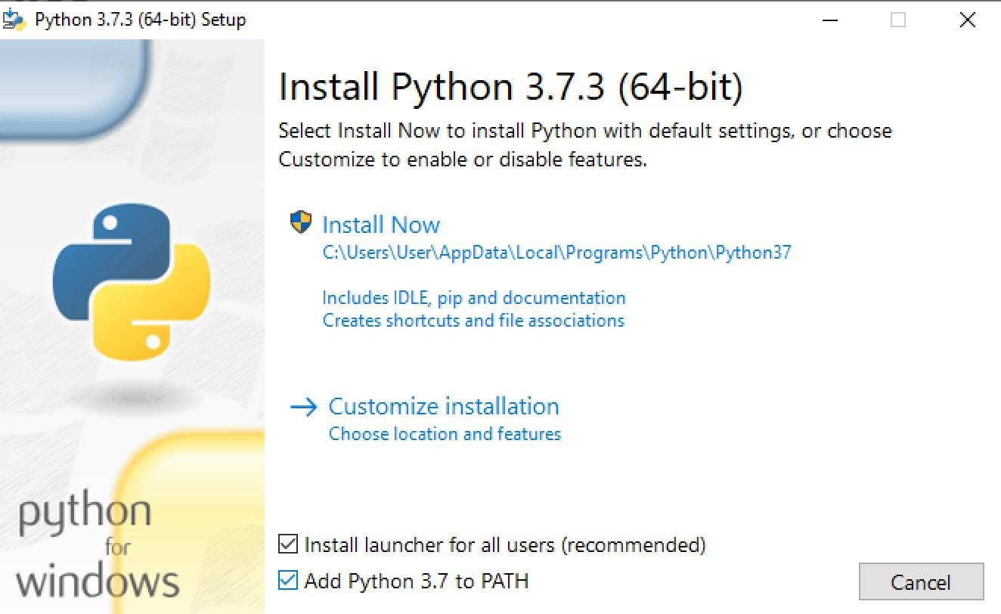

1. Install Python packages using *pip*
   1. Open a *Command Prompt* window



* 1. For example, enter the following command to install NumPy package: pip install numpy. This will download and install the package.

# Logo, icon Description automatically generatedJupyter Notebook

Jupyter supports interactive data science and scientific computing across multiple programming languages. There are two types of Jupyter software:

* **Jupyter Notebook**: open-source web application that allows you to create and share documents that contain live code, equations, visualizations and narrative text.
* **JupyterLab**: web-based interactive development environment for Jupyter notebooks, code, and data. JupyterLab will eventually replace the classic Jupyter Notebook.

You can start working with Jupyter Notebook and as you get comfortable using it, you can move on to JupyterLab later.

# Install Jupyter Notebook

* + Install Jupyter Notebook using the following command in the Command Prompt: conda install -c conda-forge notebook
  + This will in turn install several required packages and prompts for your permission to proceed. Type y and wait until the installation is complete.
  + In order to save jupyter notebooks as PDF documents, install the package [*notebook-*](https://github.com/betatim/notebook-as-pdf)[*as-pdf*](https://github.com/betatim/notebook-as-pdf)

by running the following commands:

* + - python -m pip install -U notebook-as-pdf
  + Once done, launch jupyter using the command: jupyter notebook
  + This will start the notebook server and open a new tab in the default web browser of your computer.

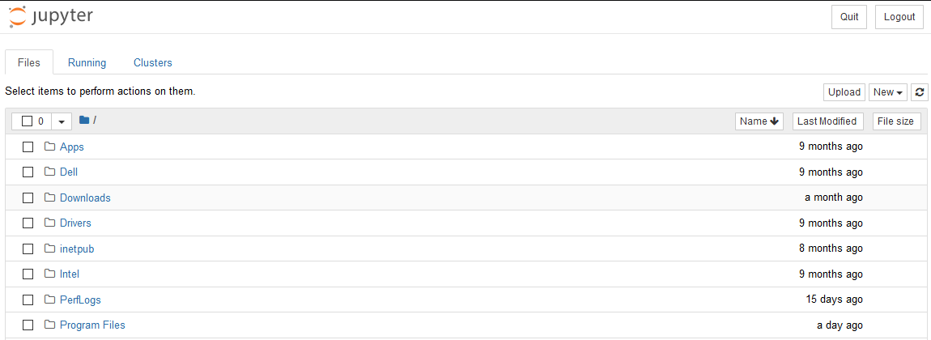

* + You can either browse to your desired directory using the Jupyter interface or navigate to the directory in the command prompt prior to launching Jupyter notebook.
  + To create a new notebook, select *Python 3* option under *New* menu.

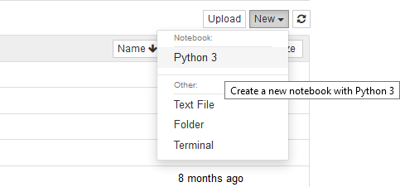

* + As a notebook opens in the new tab, make sure to select the *code* option to execute Python script. You can add text to the notebook using *markdown* option.

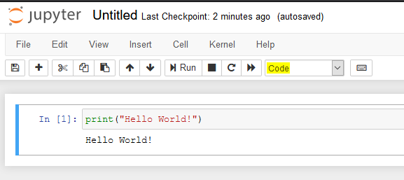

* + To save a notebook to pdf, select File menu > Download as and click on PDF via HTML option.

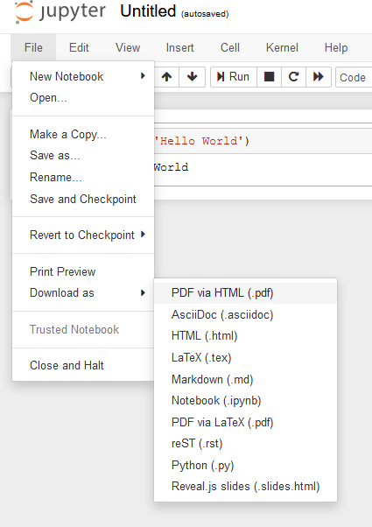

# Python Package Management:

A Python package or library is a collection of modules, functions and methods that allows for a minimal use of code during development. There are several useful data science packages for Python and we will work with a few of them in this course.

Installing a package is quite similar to the Jupyter installation you have just done. In general packages are installed through package managers like conda and pip. Just specifying the command conda install <package_name> in the Command Prompt and it will install that package if it exists in conda’s repository. If not you can always use pip install <package_name>, which is in fact the most famous and widely used package management system for Python.

Let us go over an example and install NumPy package using **conda**. In Command Prompt:

* + conda install numpy will install the NumPy package in your environment
  + Use conda list command to verify the installation or to list all packages in your environment
  + You can install a specific version of the package limited to your environment by specifying the version number like conda install numpy==1.18.1
  + conda update numpy will update the NumPy package to the latest version
  + Finally to uninstall the package, use the command conda remove numpy

As we are primarily using the **conda** package manager, use **pip** only as an alternative, that is if a package is not found through one of the conda’s channels.